Shital Digambar Bhadre
PRN NO:260740150022

Assignment 1: Basic Docker Commands

1. Verify the Docker version
docker --version
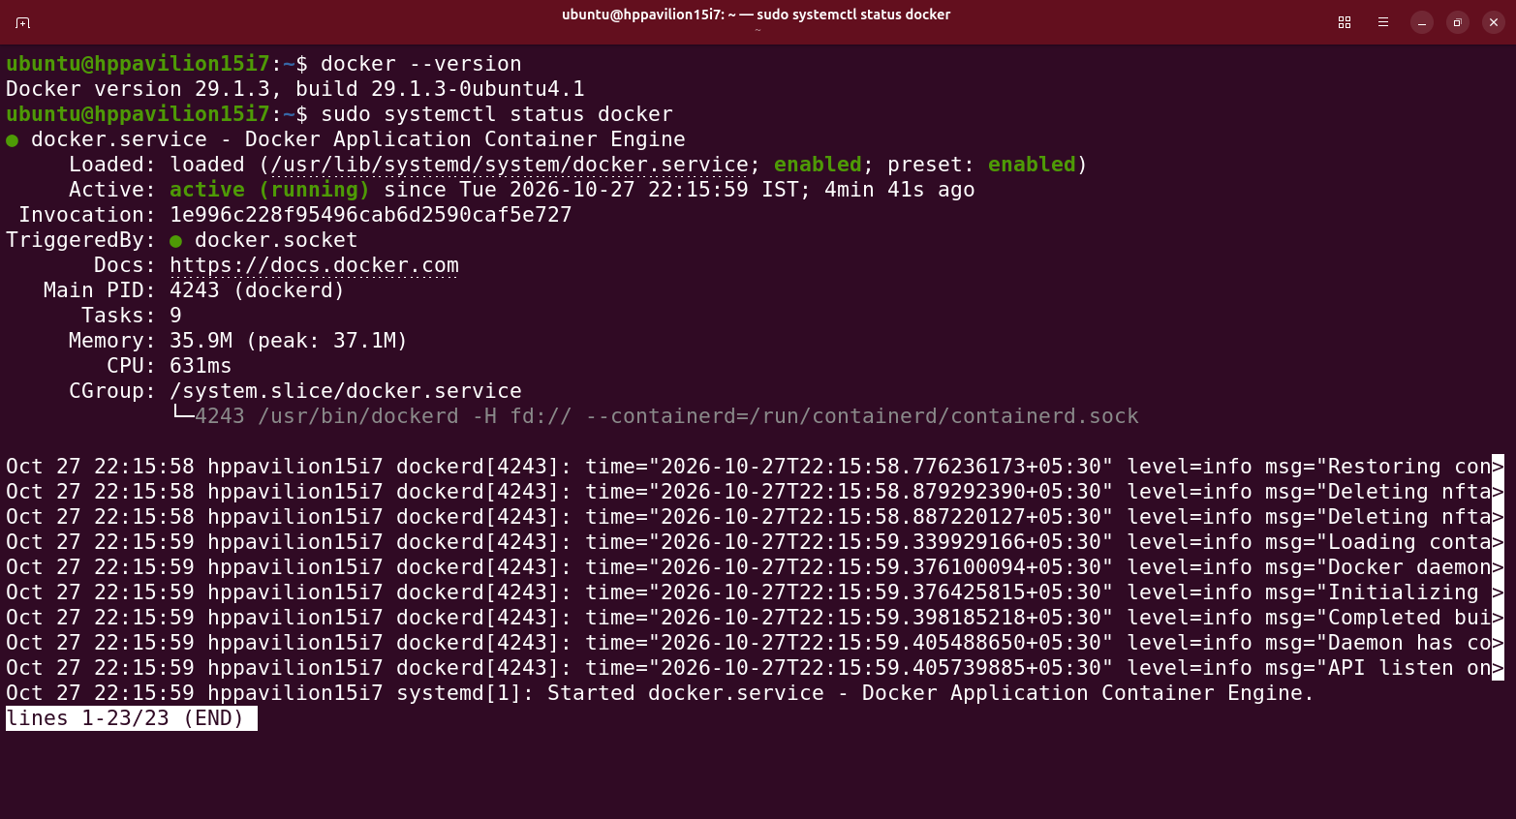

2. Check whether the Docker service is running
sudo systemctl status docker

3. Execute the hello-world container
docker run hello-world
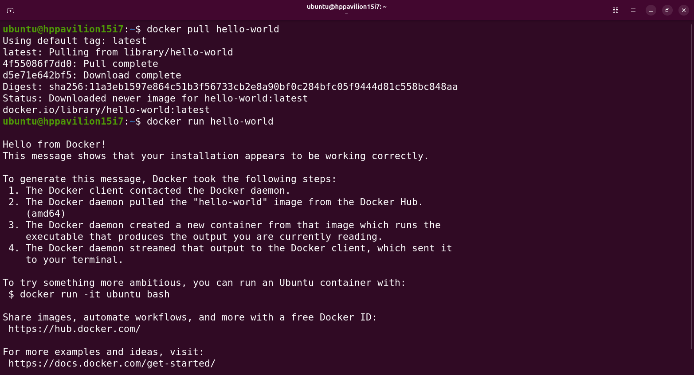

4. Display running containers
docker ps
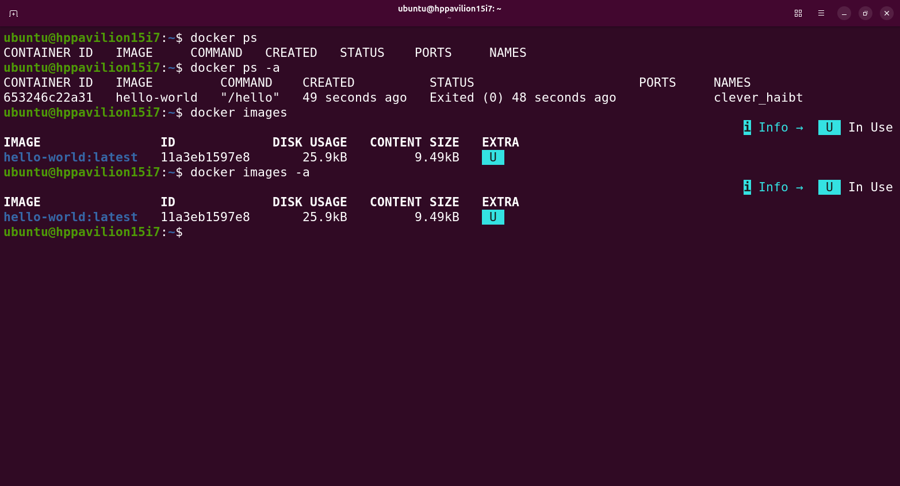

5. Display running and stopped containers
docker ps -a

6. Display downloaded images
docker images

Assignment 2: Working with an Ubuntu Container

1. Download the Ubuntu image
docker pull ubuntu
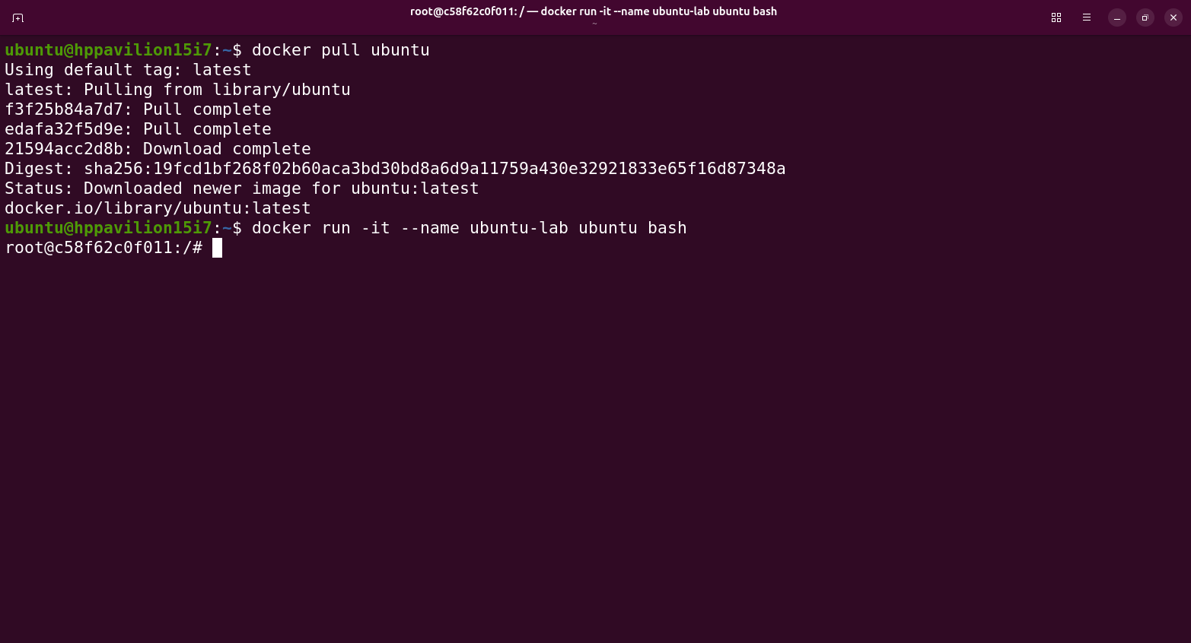
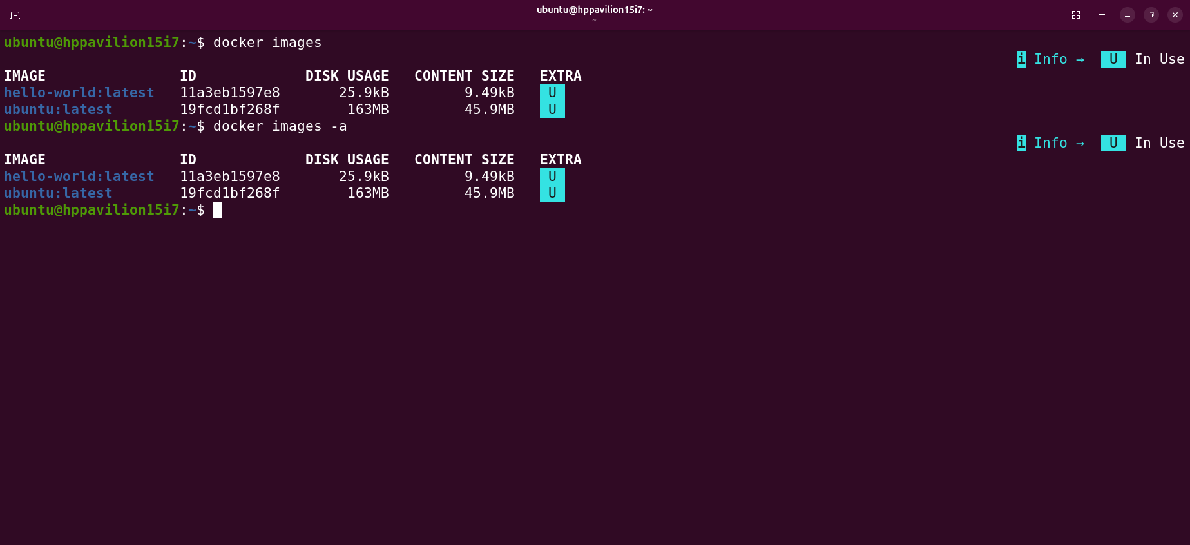

2. Create an interactive Ubuntu container
docker run -it --name ubuntu-lab ubuntu bash
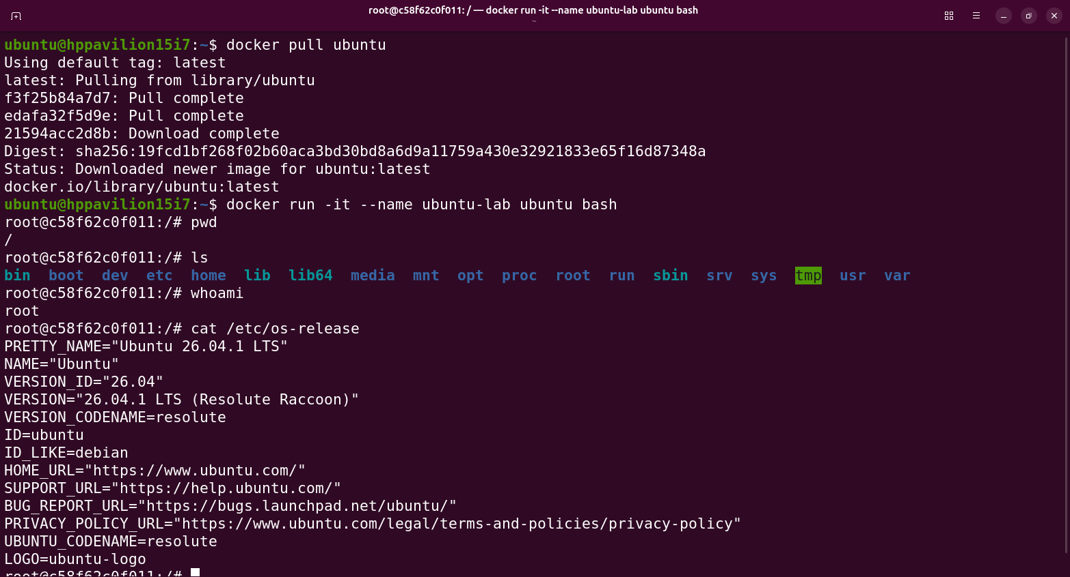

3. Execute pwd, ls, whoami, and cat /etc/os-release
pwd
ls
whoami
cat /etc/os-release

4. Create a directory named DockerLab
mkdir DockerLab
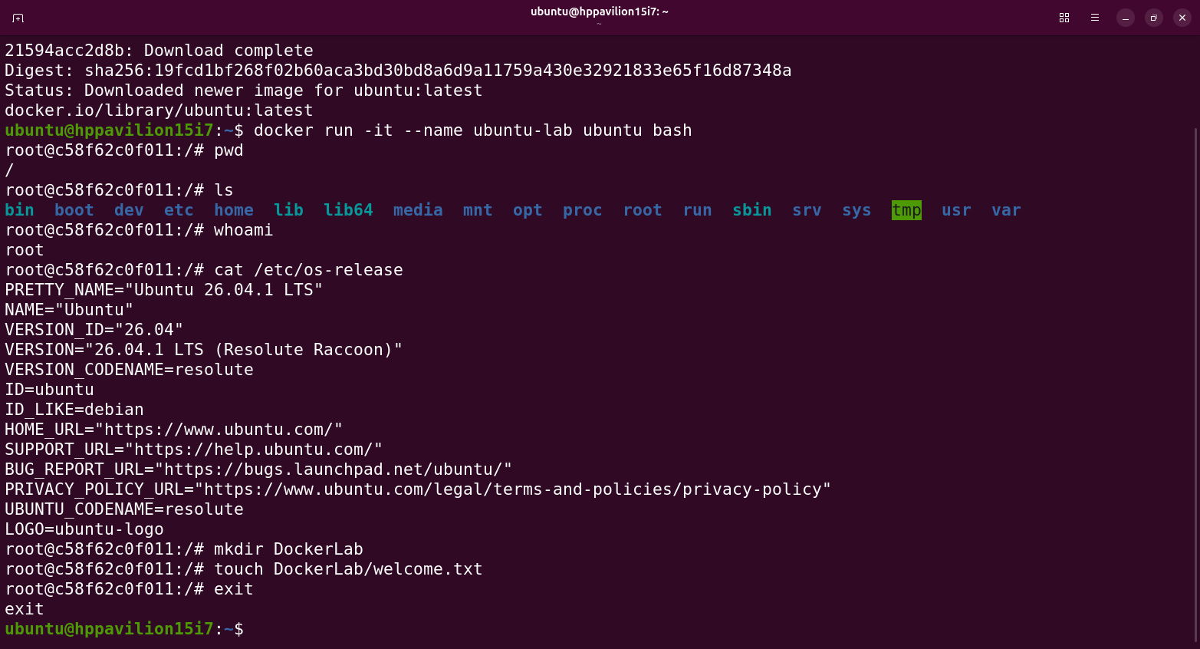

5. Create a file named welcome.txt inside it
touch DockerLab/welcome.txt
exit

6. Exit the container and check its status
exit
docker ps -a
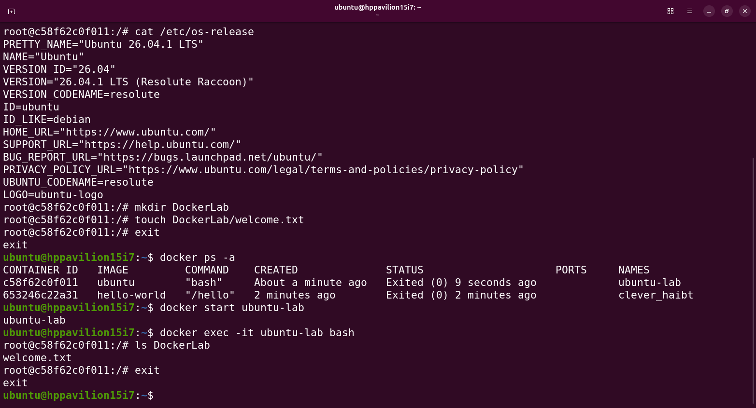

7. Restart the container and verify whether the file still exists
docker start ubuntu-lab
docker exec -it ubuntu-lab bash
ls DockerLab
exit
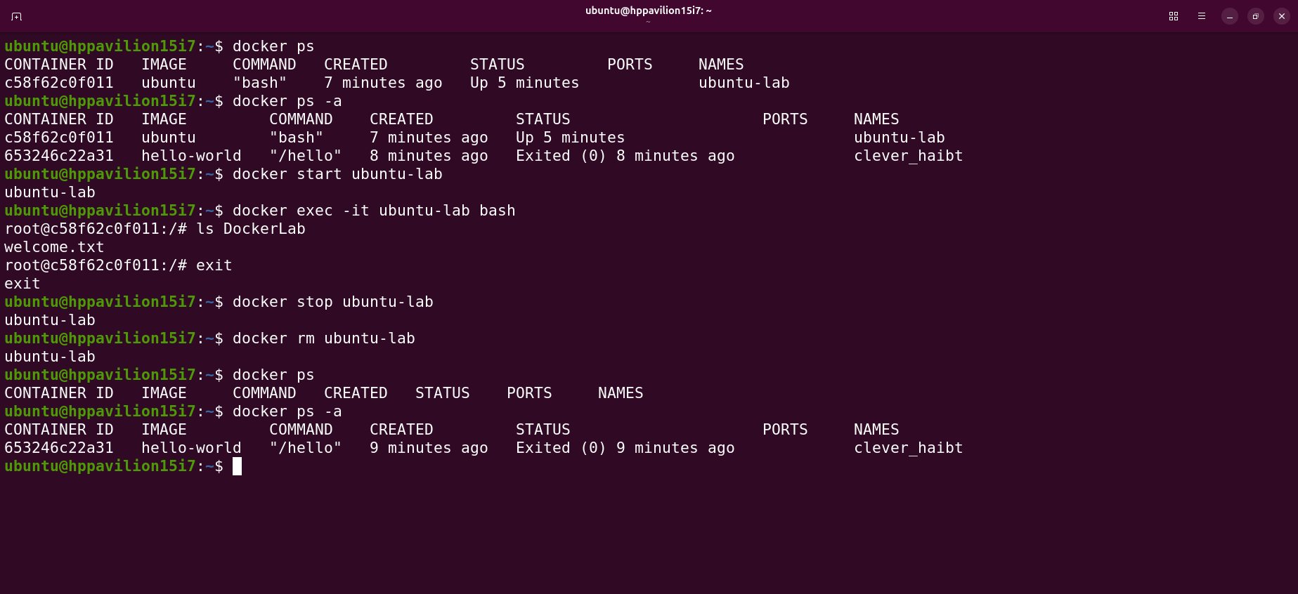

8. Remove the container
docker stop ubuntu-lab
docker rm ubuntu-lab
docker ps -a

